APPENDIX C

SOLUTIONS TO PROBLEMS

C.1 (i) This is just a special case of what we covered in the text, with n = 4: E(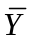) = µ and Var() = σ²/4.

(ii) E(W) = E(Y₁)/8 + E(Y₂)/8 + E(Y₃)/4 + E(Y₄)/2 = µ[(1/8) + (1/8) + (1/4) + (1/2)] = µ(1 + 1 + 2 + 4)/8 = µ, which shows that W is unbiased. Because the Y_{i} are independent,

Var(W) = Var(Y₁)/64 + Var(Y₂)/64 + Var(Y₃)/16 + Var(Y₄)/4
= σ²[(1/64) + (1/64) + (4/64) + (16/64)] = σ²(22/64) = σ²(11/32).

(iii) Because 11/32 > 8/32 = 1/4, Var(W) > Var() for any σ² > 0, so is preferred to W because each is unbiased.

C.2 (i) E(W_{a}) = a₁E(Y₁) + a₂E(Y₂) + + a_{n}E(Y_{n}) = (a₁ + a₂ + + a_{n})µ. Therefore, we must have a₁ + a₂ + + a_{n} = 1 for unbiasedness.

(ii) Var(W_{a}) = 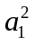Var(Y₁) + 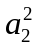Var(Y₂) + + 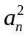Var(Y_{n}) = ( + + + )σ².

(iii) From the hint, when a₁ + a₂ + + a_{n} = 1 – the condition needed for unbiasedness of W_{a} – we have 1/n ≤ + + + . But then Var() = σ²/n ≤ σ²( + + + ) = Var(W_{a}).

C.3 (i) E(W₁) = [(n – 1)/n]E() = [(n – 1)/n]µ, and so Bias(W₁) = [(n – 1)/n]µ – µ = –µ/n. Similarly, E(W₂) = E()/2 = µ/2, and so Bias(W₂) = µ/2 – µ = –µ/2. The bias in W₁ tends to zero as n → ∞, while the bias in W₂ is –µ/2 for all n. This is an important difference.

(ii) plim(W₁) = plim[(n – 1)/n]plim() = 1µ = µ. plim(W₂) = plim()/2 = µ/2. Because plim(W₁) = µ and plim(W₂) = µ/2, W₁ is consistent whereas W₂ is inconsistent.

(iii) Var(W₁) = [(n – 1)/n]²Var() = [(n – 1)²/n³]σ² and Var(W₂) = Var()/4 = σ²/(4n).

(iv) Because is unbiased, its mean squared error is simply its variance. On the other hand, MSE(W₁) = Var(W₁) + [Bias(W₁)]² = [(n – 1)²/n³]σ² + µ²/n². When µ = 0, MSE(W₁) = Var(W₁) = [(n – 1)²/n³]σ² < σ²/n = Var() because (n – 1)/n < 1. Therefore, MSE(W₁) is smaller than Var() for µ close to zero. For large n, the difference between the two estimators is trivial.

C.4 (i) Using the hint, E(Z|X) = E(Y/X|X) = E(Y|X)/X = θX/X = θ. It follows by Property CE.4, the law of iterated expectations, that E(Z) = E(θ) = θ.

(ii) This follows from part (i) and the fact that the sample average is unbiased for the population average: write

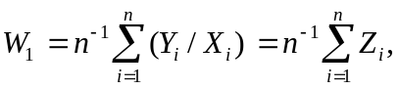

where Z_{i} = Y_{i}/X_{i}. From part (i), E(Z_{i}) = θ for all i.

(iii) In general, the average of the ratios, Y_{i}/X_{i}, is not the ratio of averages, 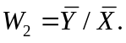 (This non-equivalence is discussed a bit on page 676.) Nevertheless, W₂ is also unbiased, as a simple application of the law of iterated expectations shows. First, E(Y_{i}|X₁,…,X_{n}) = E(Y_{i}|X_{i}) under random sampling because the observations are independent. Therefore, E(Y_{i}|X₁,…,X_{n}) = 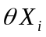 and so

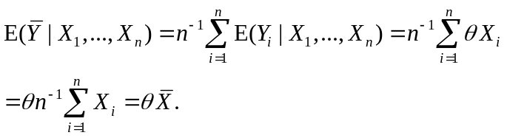
Therefore, which means that W₂ is actually unbiased conditional on 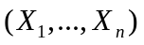, and therefore also unconditionally unbiased.

(iv) For the n = 17 observations given in the table – which are, incidentally, the first 17 observations in the file CORN.RAW – the point estimates are w₁ = .418 and w₂ = 120.43/297.41 = .405. These are pretty similar estimates. If we use w₁, we estimate E(Y|X = x) for any x > 0 as 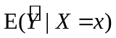 = .418 x. For example, if x = 300 then the predicted yield is .418(300) = 125.4.

C.5 (i) While the expected value of the numerator of G is E() = θ, and the expected value of the denominator is E(1 – ) = 1 – θ, the expected value of the ratio is not the ratio of the expected value.

(ii) By Property PLIM.2(iii), the plim of the ratio is the ratio of the plims (provided the plim of the denominator is not zero): plim(G) = plim[/(1 – )] = plim()/[1 – plim()] = θ/(1 – θ) = γ.

C.6 (i) H₀: µ = 0.

(ii) H₁: µ < 0.

(iii) The standard error of is 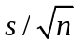 = 466.4/30 15.55. Therefore, the t statistic for testing H₀: µ = 0 is t = /se() = –32.8/15.55 –2.11. We obtain the p-value as P(Z ≤ –2.11), where Z ~ Normal(0,1). These probabilities are in Table G.1: p-value = .0174. Because the p-value is below .05, we reject H₀ against the one-sided alternative at the 5% level. We do not reject at the 1% level because p-value = .0174 > .01.

(iv) The estimated reduction, about 33 ounces, does not seem large for an entire year’s consumption. If the alcohol is beer, 33 ounces is less than three 12-ounce cans of beer. Even if this is hard liquor, the reduction seems small. (On the other hand, when aggregated across the entire population, alcohol distributors might not think the effect is so small.)

(v) The implicit assumption is that other factors that affect liquor consumption – such as income, or changes in price due to transportation costs, are constant over the two years.

C.7 (i) The average increase in wage is = .24, or 24 cents. The sample standard deviation is about .451, and so, with n = 15, the standard error of is 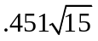 .1164. From Table G.2, the 97.5th percentile in the t₁₄ distribution is 2.145. So the 95% CI is .24 ± 2.145(.1164), or about –.010 to .490.

(ii) If µ = E(D_{i}) then H₀: µ = 0. The alternative is that management’s claim is true: H₁: µ > 0.

(iii) We have the mean and standard error from part (i): t = .24/.1164 2.062. The 5% critical value for a one-tailed test with df = 14 is 1.761, while the 1% critical value is 2.624. Therefore, H₀ is rejected in favor of H₁ at the 5% level but not the 1% level.

(iv) The p-value obtained from Stata is .029; this is half of the p-value for the two-sided alternative. (Econometrics packages, including Stata, report the p-value for the two-sided alternative.)

C.8 (i) For Mark Price, = 188/429 .438.

(ii) Var() = θ(1 – θ)/n [because the variance of each Y_{i} is 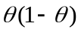 and so sd() =
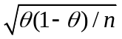.

(iii) The asymptotic t statistic is (− .5)/se(); when we plug in the estimate for Mark Price, se() = 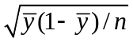 = 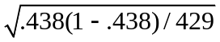 .024. So the observed t statistic is (.438 – .5)/.024 –2.583. This is well below the 5% critical value (based on the standard normal distribution), –1.645. In fact, the 1% critical value is –2.326, and so H₀ is rejected against H₁ at the 1% level.

C.9 (i) X is distributed as Binomial(200,.65), and so E(X) = 200(.65) = 130.

(ii) Var(X) = 200(.65)(1 − .65) = 45.5, so sd(X) 6.75.

(iii) P(X ≤ 115) = P[(X – 130)/6.75 ≤ (115 – 130)/6.75] P(Z ≤ –2.22), where Z is a standard normal random variable. From Table G.1, P(Z ≤ –2.22) .013.

(iv) The evidence is pretty strong against the dictator’s claim. If 65% of the voting population actually voted yes in the plebiscite, there is only about a 1.3% chance of obtaining 115 or fewer voters out of 200 who voted yes.

C.10 Since = .394, se() .024. We can use the standard normal approximation for the 95% CI: .394 ± 1.96(.024), or about .347 to .441. Therefore, based on Gwynn’s average up to strike, there is not very strong evidence against θ = .400, as this value is well within the 95% CI. (Of course, .350 is within this CI, too.)

